**Name – Ratan Tyagi**

**Enroll – 1810DMBCSE03311**

**Branch – B.tech+MBA [I Section]**

**2nd year/4th sem**

**OBJECTIVE**:-A Small shop having less quantity item want to control his/her billing through system with proper GST and Delivery charges.

**Users Of System**:-ShopKeeper Panel

**Functional Requirment**:-Calculate the total amount of product with its quantity details….By clicking on CALCULATE BUTTON.

**Tool Used** :-Use any IDE to develop the PROJECT in NETBEANS IDE VERSION 8.2RC

**WORKING OF PROJECT:-**

1. OPEN NETBEANS IDE SOURCE CODE AND RUN THE CODE

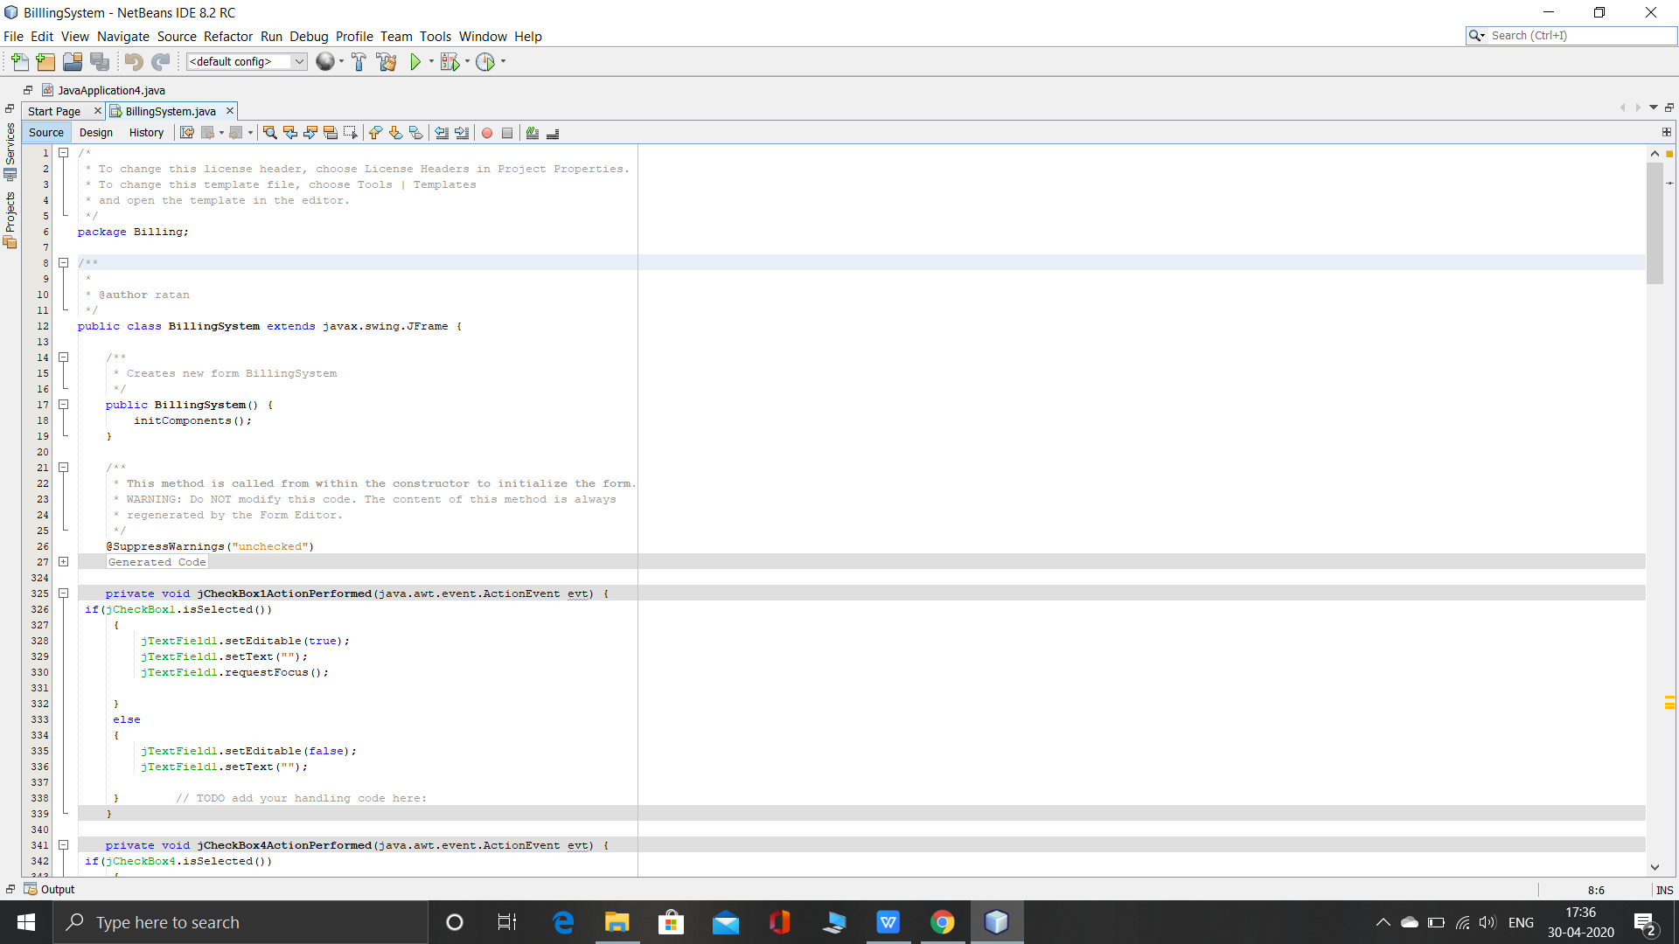

**2.WELCOME PAGE**

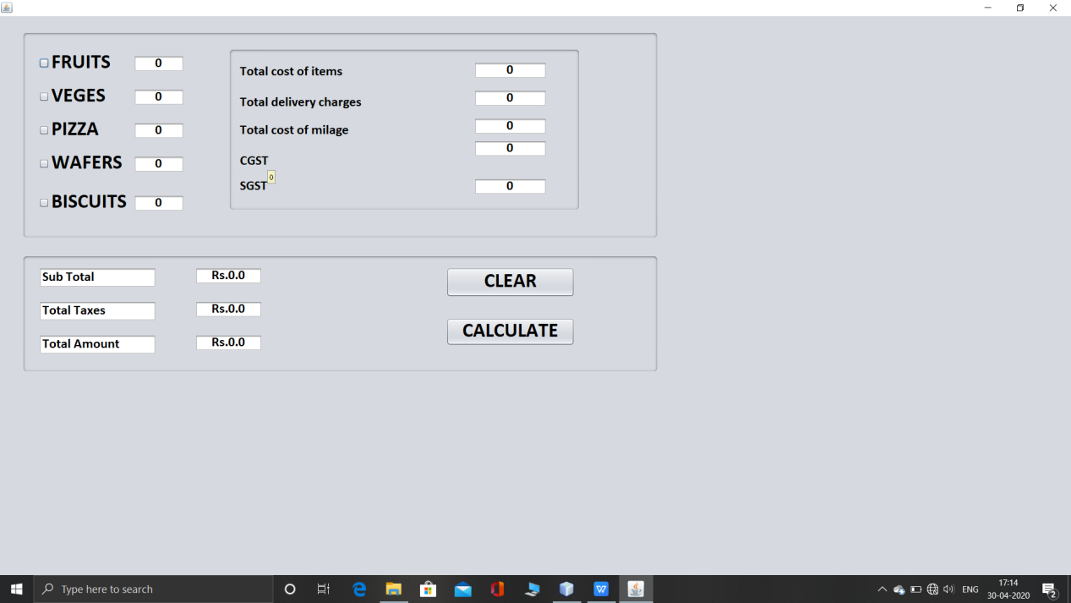

**3.SELECTED THE ITEM ONLY YOU CAN EDIT THE QUANTITY….OTHERWISE THE QUANTITY IS NON EDITABLE.**

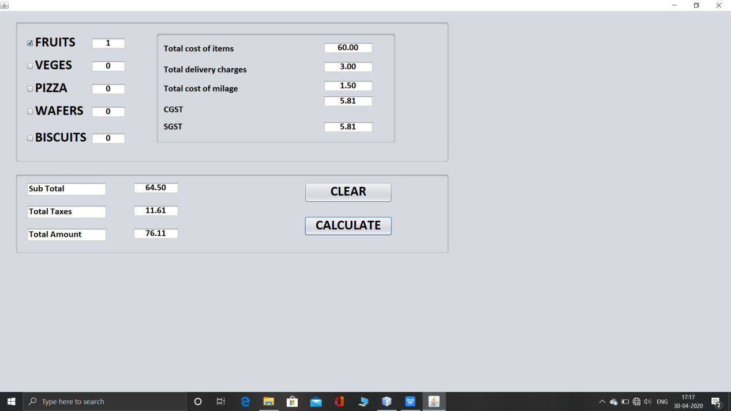

Clicking on calculate button you get the price of of each whole item with

1. Total cost of items
2. Total delivery charge which is 5% of the total cost
3. Milage cost is half of the delivery charge
4. CGST is 9% of the total cost
5. SGST is 9% of the total cost
6. Subtotal include (total cost+delivery charge+total mileage cost)
7. Totalis (cgst+sgst)
8. Total amount is the final amount that a customer has to pay to the user.

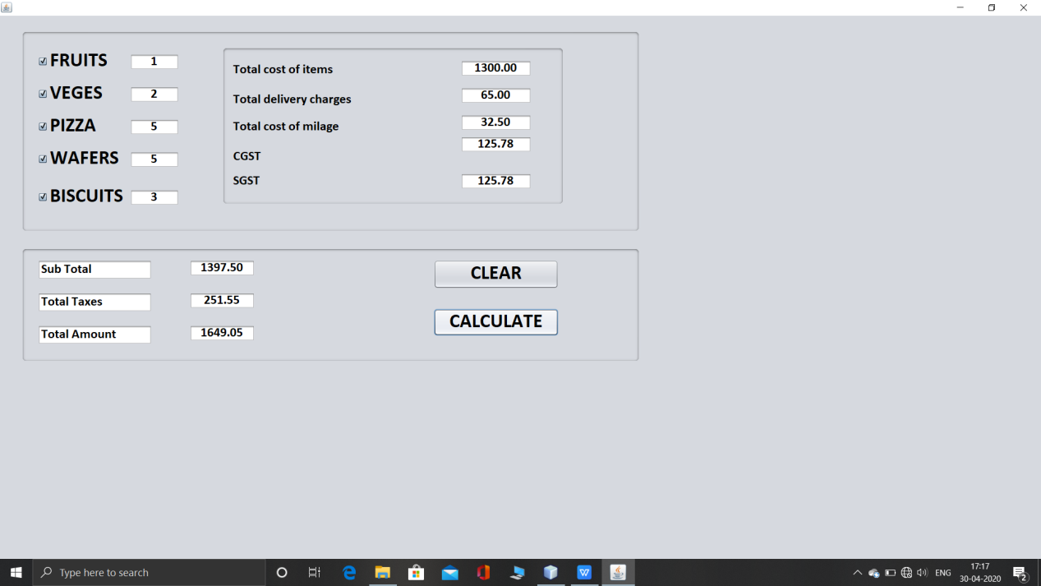

**CLEAR BUTTON CLEAR ALL THE ENTRIES DONE IN HISTORY AND GET BACK TO THE WELCOME PAGE**

